Worksheet 1.4: Street light
- Complete the truth table for the NOT gate.
Remember, the NOT gate inverts an input of 1 to an output of 0 and an input of 0 to an output of 1.
In | Out
0
1

- An automated street light is connected to two switches, an input from a timer and an input from a light sensor. An OR gate is used to control the street light. Input A, input B or both inputs A and B must be on for the street light to light up.
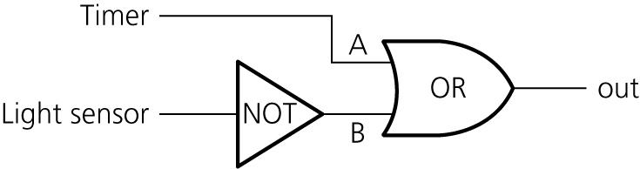
The timer is connected to input A. The timer switch is on between 6 p.m. and 6 a.m.
The light sensor is connected to input B. The light sensor switch is on when light shines on the sensor., the input to the gate will be on or 1.
We do not want the street light to come on during daylight hours so the control system makes use of a NOT gate between the light sensor and input B of the OR gate.
Complete the truth table for the automated street light. Use the diagrams to help you complete the truth table, modelling the inputs and outputs by adding a 1 or a 0 to each box.

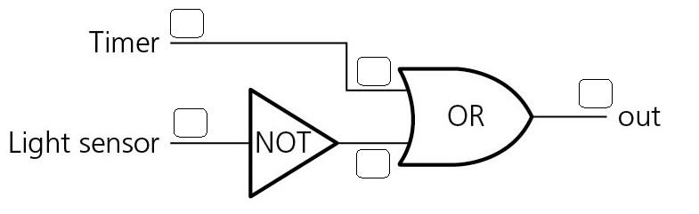

Timer | Light sensor | Street light

